(Approx. 415 words)

Nite-Ize
A review by George Harding, Treasurer
June 2017
Tucson Computer Society
www.aztcs.org
georgehardingsbd (at) earthlink.net

This company has a wide range of useful products and the list keeps getting longer. The employees think up more and more useful things for us to use.

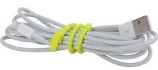
One of their products, Gear Tie, is a most useful product and comes in a range of sizes, from the tiny 3-inch ones to the 64-inch monsters. Each has its uses.
I use the 6-inch Gear Ties to tame my charge cords. I believe these cords have wrestling matches while they are packed away! They always come out tangled, no matter how carefully I pack them.

Some of the Gear Ties come with a rubberized surface, to provide more friction in their restraining job.

Of course, color is an option as well as length. You can have yellow, blue, black or red.
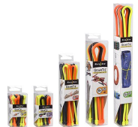
There are variations in design, too. Some have a ring fastened at the end, which gives you the option to cinch, twist, hang whatever it is that needs that feature. Other Gear Ties have a clip at one end, to make attachment to loops, bars and O-rings easy.

The 64-inch Gear Tie is great for cinching down stuff to your car roof or truck bed.

All in all, the Gear Tie line is versatile and flexible to meet all your needs.
Another useful product is the Inova line of LED flashlights. These range from 110 lumens to 1075 lumens. The body is tough plastic and is longer than a common flashlight. It is easy to hold and has a switch that allows a selection of beams: very bright, flashing, normal light but circular and more.

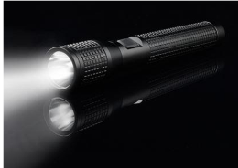
I received a T5 1075 lumen Inova flashlight for review and I was quite impressed with it. The body is 9 inches long and produces a very strong light, capable of reaching over 900 feet! It is hard to describe the very high intensity of the light.

The body has a cross-hatched surface, which makes it very easy to hold on to, even when wet. The flashlight is well balanced, as well.

A nice extra feature of Nite-Ize products is that they are 100% guaranteed. If there is a problem, just call them for repair, replacement or exchange.

Nite-Ize products
www.niteize.com
The price of Gear Ties varies from $3 for a 4 pack of 3 inchers, to $6 for the 64 incher (Amazon).

The price of the Inova T5 flashlight is $84 on Amazon.

